Project Title : Content Marketing Plan Template Based on HubSpot

NM Id : DDA9CBF432CA23B932244481FEA55216

Industry Mentor(s) Name : Abdul Malic

### Project Design Phase - Part 1

**Proposed Solution:**

* Customer Connection: We'll get to know our customers better—what they like, how they shop, and what they're willing to spend.
* Stand Out from the Crowd: We'll find what makes our boutique special and use it to attract shoppers over competitors.
* Online Upgrade: We'll improve our website and social media to make them more appealing and easy to use.
* Share Expertise: We'll start a blog to share fashion tips and trends, positioning our boutique as a go-to for style advice.
* Reward Loyalty: We'll introduce a rewards program to thank our regulars and encourage them to spread the word.
* Exciting Events: We'll host fun events andworkshops to engage and educate our customers.
* Go Green: We'll promote eco-friendly fashion to attract shoppers who care about the environment.
* Special Deals: We'll offer seasonal discounts and promotions to draw in more shoppers.
* Learn and Improve: We'll keep an eye on what's working, listen to feedback, and adjust our strategies for even better results

**Solution Architecture**

* 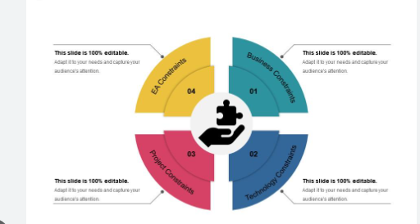
* Customer Relationship Management (CRM) System:
  + Purpose: To store and manage customer information, preferences, and purchase history.
  + Components: CRM software, customer database.
* Website and E-commerce Platform:
  + Purpose: To provide an online presence for the boutique and facilitate e-commerce transactions.
  + Components: Website, product catalog, shopping cart, payment gateway.
* Content Management System (CMS):
  + Purpose: To manage and update the boutique's website content, including the blog section.
  + Components: CMS software, blog interface.
* Social Media Management Tool:
  + Purpose: To schedule and manage social media posts and engagements.
  + Components: Social media management platform.
* Email Marketing Platform:
  + Purpose: To manage and send personalized email campaigns, including newsletters and promotions.
  + Components: Email marketing software.
  + 